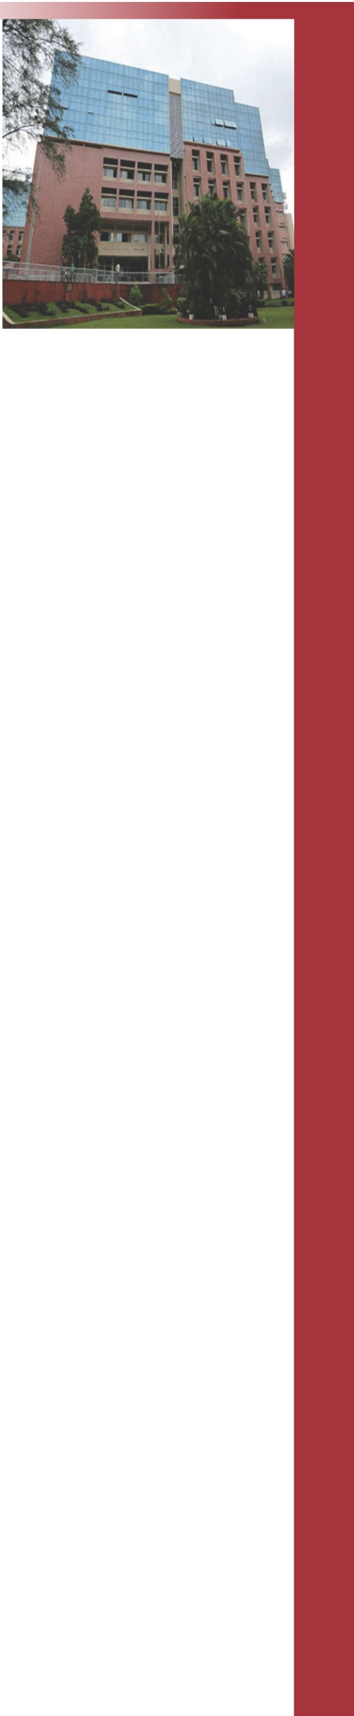

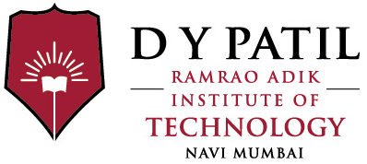

Hands-on Session

on

*“Python Web Development with Django Framework”*

Certificate of Participation

This is to certify that ${name}

has participated in the Hands-on session on ***${event}*** conducted by Department of Computer Engineering at Ramrao Adik Institute of Technology, Nerul, Navi Mumbai on 23,March 2018.

Dr. Leena Ragha

Head, Computer Engg.

Workshop Co-ordinator

 [**www.rait.ac.in**](http://www.rait.ac.in/)